**Meet the Teacher**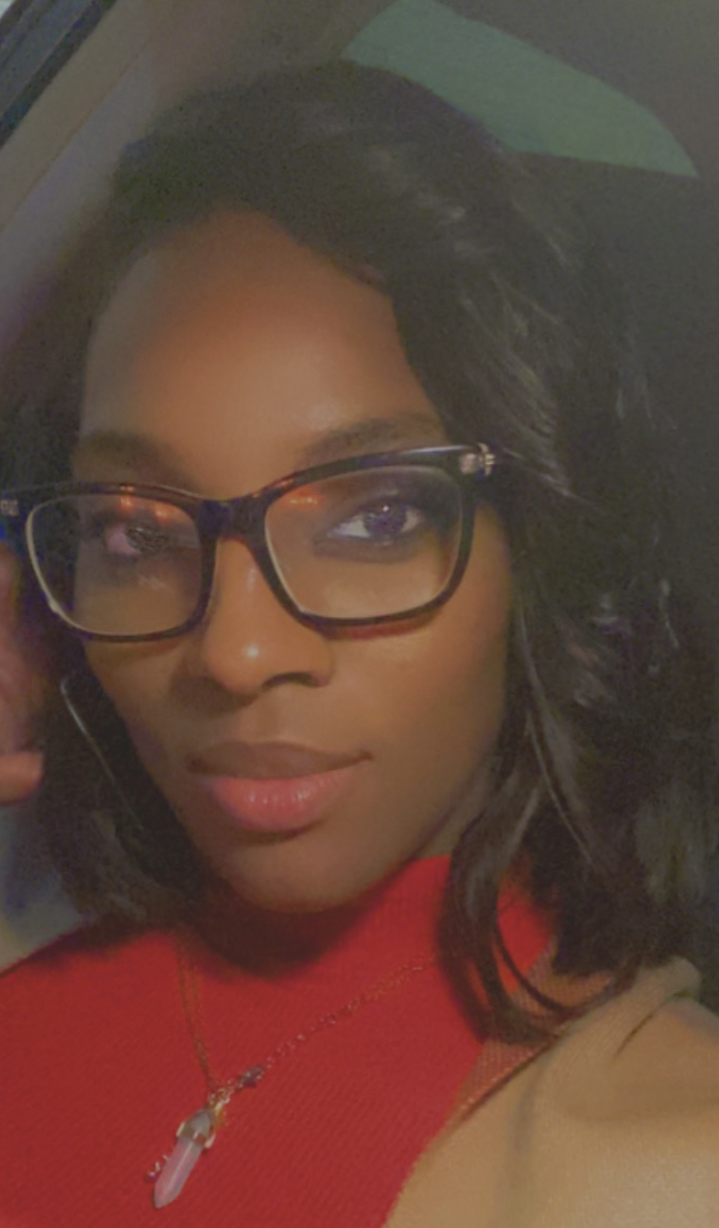

Welcome to Kindergarten! I am Mrs.Webb and I am very excited to be your child's teacher this year! I am looking forward to developing positive relationships with you and your child for their growth. I will take care of your child with love, kindness, and respect. The same as I would want for my own children. I have always had a love for children. This will be a year of fun and learning.

I grew up in Lincolnton, GA. I received my bachelor’s degree from Georgia Southern University. I am working towards my master’s degree from University of Phoenix. I enjoy spending time with my family. My husband and I have three children 1 girl and 2 boys.

I have a fear of flying.

About Me:

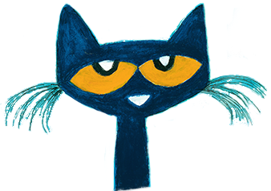

**Email:** [**webbce@boe.richmond.k12.ga.us**](mailto:webbce@boe.richmond.k12.ga.us)

**Phone: 706- 481-1813**

**Class dojo:** [**https://www.classdojo.com/invite/?s=4eece67ef64aa62934ed57aa**](https://www.classdojo.com/invite/?s=4eece67ef64aa62934ed57aa)

Hobbies: Listening to music, shopping

Candy: Turtles

Colors: Teal, Mustard Yellow, & Olive Green Drinks: Coke, Water, and Vanilla frap w/ dragon fruit

Favorite show: Family Feud

My favorites:

Contact: